NATIONAL UNIVERSITY OF MODERN LANGUAGE ISLAMABAD
Lab 06


Submitted to:
Sir Hassan Shah
Submitted by:
Zulqarnain Hassan
Roll No: …………………… SP21379
Subject: …………………… computer network
Department: ……………… BSSE-5-Afternoon
Date: ……………………… 01-12-2024

Objectives:
- Create and configure VLANs in Cisco packet tracer.
- Study the Router on a Stick Configuration.
- Learn to Configure native VLAN in Cisco packet tracer and Fix native VLAN mismatch.
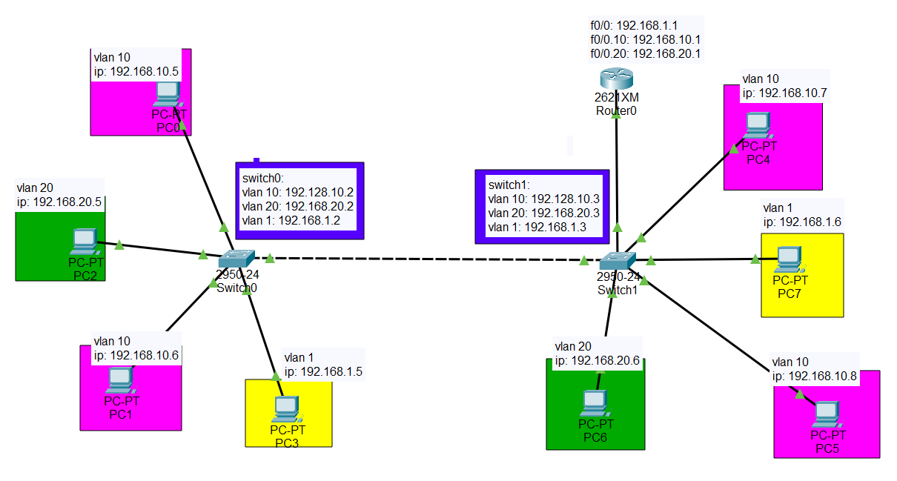

Task 1
set IP address and default gateway to pcs.
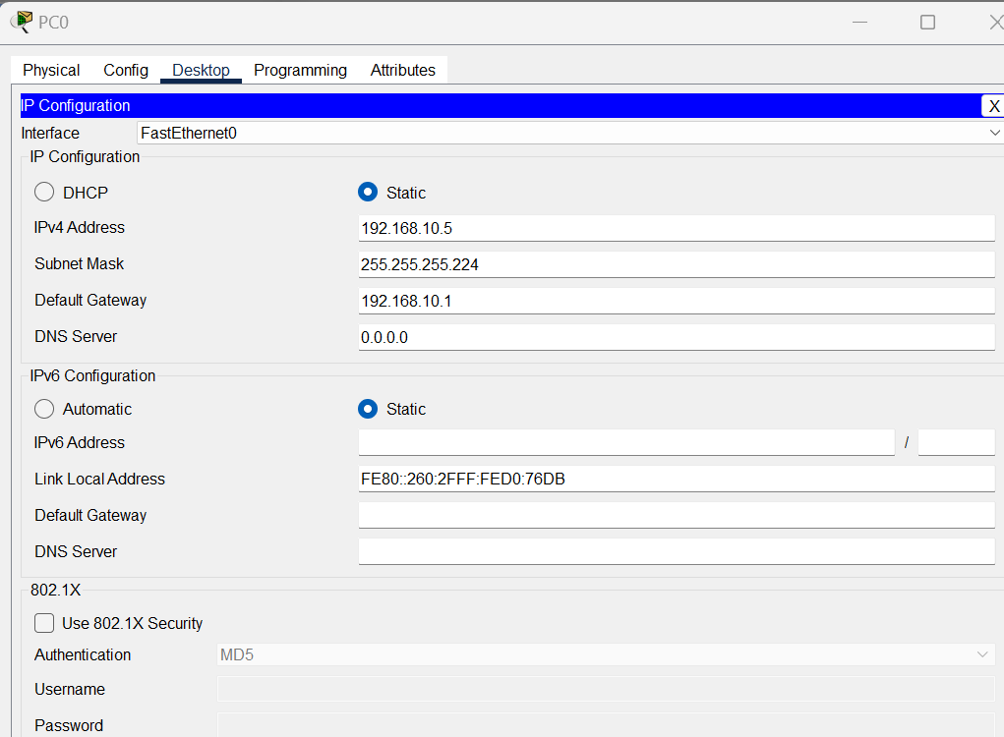

Task 2
Creating Vlan
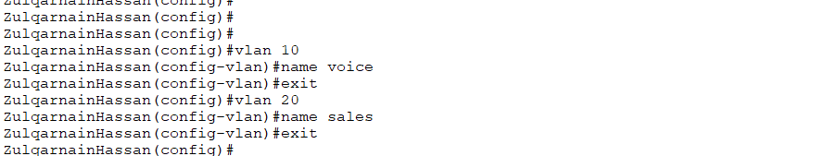
Allocating multiple ports to a Vlan.
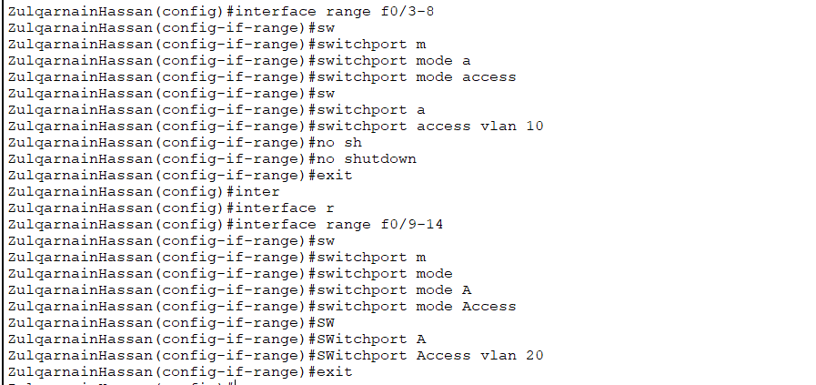

Task3

Trunking port.

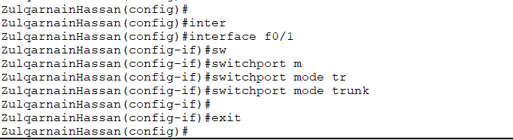

Task 4

setting up a subinterface on a router.

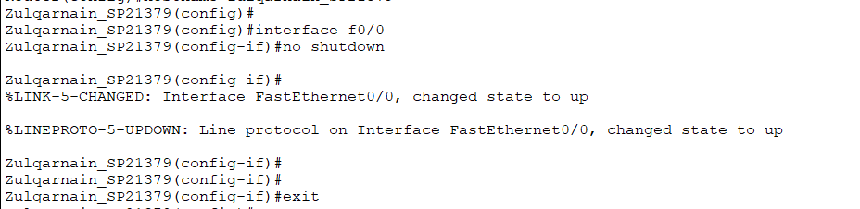
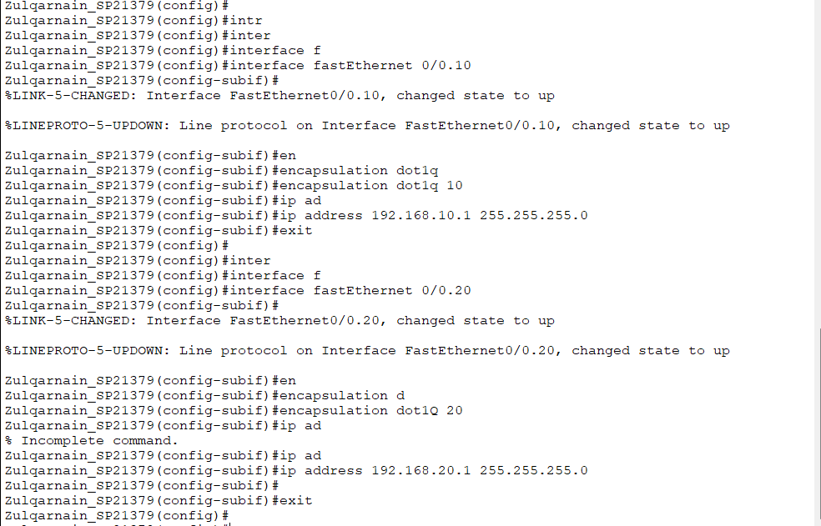

Assigning IP addresses to vlans.
